EX:1 8-queen problem
Date:22/07/2026

Program:

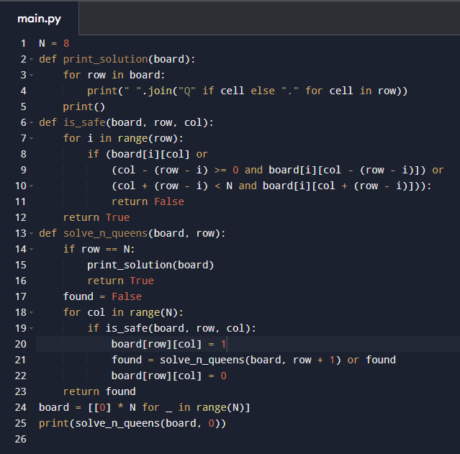

Output:

